IDENTIFICATION FORM
HORSE’S NAME:___________________________________________________________________
Indicate ALL markings in the following diagrams:
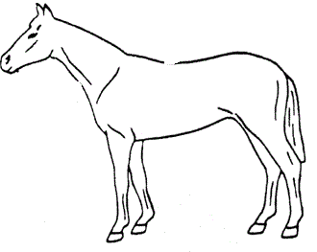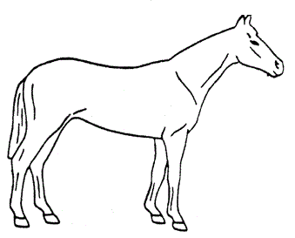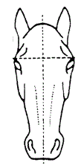
SERVICE CERTIFICATE
If you did NOT own BOTH Mare and Stallion at time of service please complete this section as a Service Certificate.
No alteration of information in this section is acceptable.
This is to certify___________________________________
Name of Stallion & Reg. No.
Was Bred to ______________________________________
Name of Mare served & Reg No.
___________________________________20_____
List dates or breeding season
_____________________________________
Signature of owner of Stallion at time of service
______________________________________
Signature of owner of Mare at time of service

Head
Off Side
Near Side

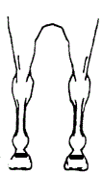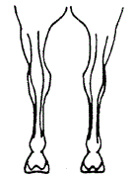
Hind legs
Fore Legs

I hereby certify that the above markings are correct.
Signature________________________
Date_____/______/_______

Height Certificate
This section must be completed on all horeses 60 months of age and over to be registered.
Name of Horse_______________________________________________________________
I hereby certify that the above horse was measured according to NMHSNZ (Inc) regulations and found to be _______________________inches in height.
I further certify that to the best of my knowledge, the horse is ____________months/years of age. In signing this statement, I accept responsibility for the information submitted and understand any misrepresentations on my part will render this certificate null and void and I will be subject to penalty and/or suspension.

_____________________________________________ __________________________
Height measured
______________________________________________ __________________________
Name & Address of measurer Date Measured

_________________________________________ _____________________________
Signature of Measurer Signature of Owner

